SIMATS ENGINEERING
ASSESSMENT TOOL 1: Experiments

COURSE NAME: Cloud Computing and
Big Data Analytics

COURSE CODE: CSA15

COURSE OUTCOME COVERED
CO3: Implement cloud-based solutions using cloud storage, web APIs, and platform services for real-world
applications. (BL3)
Assessment Tool Weightage: 40%
Dave&#39;s Taxonomy: Precision (Level 3)
Question Count: 5

Total Marks: 40

Code of Conduct
I ARTHIREDDY(192565054)(Name / Reg No) certify that this submission is my original work and that I have adhered
to the guidelines specified for this assessment.
I understand that any violation of academic integrity rules will result in disciplinary action.
Signature of the student: arthireddy
Assessment Tasks
Experiments
1. Experiment 1: Create and document a cloud storage comparison between object, block, and file storage. Select
the best storage model for backups, VM disks, and shared enterprise documents.
2. Experiment 2: Develop a simple REST API workflow for a cloud-based student portal. Show request, response,
authentication, and deployment flow.
3. Experiment 3: Design a serverless event flow for image upload processing using object storage, function-as-a-
service, and notification service.
4. Experiment 4: Compare edge computing and fog computing for a smart traffic management system. Include
architecture, latency considerations, and deployment location.
5. Experiment 5: Demonstrate a cloud application deployment workflow showing client access, browser
interaction, web API call, storage access, and monitoring.
For each experiment, include objective, architecture sketch, procedure, expected output, and conclusion.
Experiments Rubric
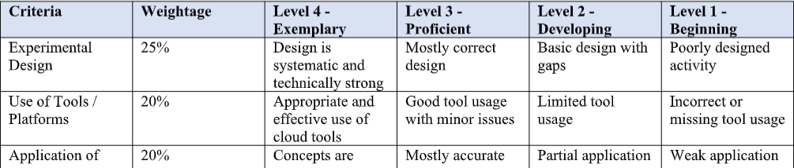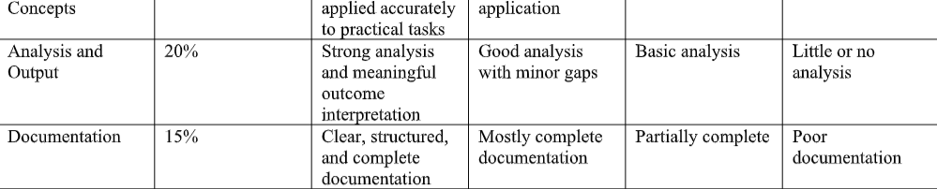

Cloud Computing – Experiments 1 to 5
Experiment 1: Cloud Storage Comparison
Objective
To compare Object, Block, and File Storage and select the best storage model for backups, VM disks, and shared enterprise documents.
Architecture Sketch
Cloud Storage
|
+-------------+-------------+
| | |
Object Storage Block Storage File Storage
| | |
Backups VM Disks Shared Files
| | |
Files/Images Databases Documents
Comparison
Feature | Object Storage | Block Storage | File Storage
Data unit | Object | Block | File
Access | API/HTTP | Attached disk | File system
Scalability | Very high | High | High
Best use | Backup, media | VM disks, databases | Shared documents
Example | Amazon S3 | Amazon EBS | Amazon EFS
Procedure
- Identify the requirements of the application.
- Compare object, block, and file storage.
- Analyze scalability, performance, and accessibility.
- Select the appropriate storage model.
- Document the results.
Expected Output
- Backups → Object Storage
- VM Disks → Block Storage
- Shared Enterprise Documents → File Storage
Conclusion
Object storage is best for large-scale backups, block storage is suitable for VM disks and high-performance applications, and file storage is suitable for shared enterprise documents.

Experiment 2: REST API Workflow for Cloud Student Portal
Objective
To develop and demonstrate a simple REST API workflow for a cloud-based student portal including request, response, authentication, and deployment.
Architecture Sketch
Student
|
v
Browser / Mobile App
|
| HTTPS Request
v
Authentication
|
v
REST API
|
v
Cloud Database
|
v
JSON Response
|
v
Student Portal
Procedure
- Create a student portal application.
- Create REST API endpoints.
- Implement authentication using a token/API key.
- Send an HTTP request to the API.
- Validate the authentication token.
- Process the request.
- Retrieve student information from the cloud database.
- Return the result as a JSON response.
- Deploy the API to a cloud server/platform.
Example Request
GET /api/students/101
Authorization: Bearer TOKEN123
Example Response
{
"id": 101,
"name": "Arthi",
"course": "Computer Science",
"status": "Active"
}
Expected Output
Request → Authentication → REST API → Database
↓
JSON Response
Conclusion
REST APIs provide a simple and standardized way for cloud applications to communicate with databases and other services securely.

Experiment 3: Serverless Image Processing
Objective
To design a serverless event-driven architecture for processing images uploaded to cloud object storage.
Architecture Sketch
User
|
v
Image Upload
|
v
Object Storage
|
Upload Event
|
v
Function-as-a-Service
|
+-----+------+
| |
Resize Image Generate
Thumbnail
| |
+-----+------+
|
v
Notification Service
|
v
User
Procedure
- Create a cloud object-storage bucket.
- Allow users to upload images.
- Configure an upload event.
- Connect the event to a serverless function.
- The function receives the uploaded image information.
- Process the image, such as resizing or thumbnail generation.
- Store the processed image.
- Trigger a notification service.
- Send a notification to the user.
Expected Output
Image Uploaded
↓
Event Generated
↓
Serverless Function Executed
↓
Image Processed
↓
Notification Sent
Conclusion
Serverless architecture automatically executes image-processing functions when an event occurs. It reduces infrastructure management and can scale automatically according to demand.

Experiment 4: Edge vs Fog Computing for Smart Traffic Management
Objective
To compare Edge Computing and Fog Computing for a smart traffic management system based on architecture, latency, and deployment location.
Architecture Sketch
Edge Computing:
Traffic Sensors
|
v
Edge Device
|
v
Traffic Signal
Fog Computing:
Traffic Sensors
|
v
Fog Node / Gateway
|
v
Regional Cloud
|
v
Central Cloud
Comparison
Feature | Edge Computing | Fog Computing
Processing location | Near sensor/device | Between edge and cloud
Latency | Very low | Low
Bandwidth usage | Very low | Low
Deployment | Traffic controller/camera | Local gateway/regional server
Best use | Immediate decisions | Regional coordination
Procedure
- Install traffic sensors and cameras.
- Collect vehicle and traffic data.
- For edge computing, process data directly near the traffic signal.
- For fog computing, send data to a nearby fog node.
- Analyze traffic conditions.
- Adjust traffic signals based on the analysis.
- Send important information to the central cloud for long-term analysis.
Expected Output
Heavy Traffic Detected
↓
Local Processing
↓
Traffic Signal Timing Changed
↓
Reduced Waiting Time
Conclusion
Edge computing is preferred when very low latency is required for immediate traffic decisions. Fog computing is useful when multiple nearby traffic devices need coordinated regional processing.

Experiment 5: Cloud Application Deployment Workflow
Objective
To demonstrate a cloud application workflow involving client access, browser interaction, web API calls, storage access, and monitoring.
Architecture Sketch
User
|
v
Web Browser
|
HTTPS
|
v
Cloud Web App
|
v
Web API
/ \
/ \
v v
Cloud Storage Database
|
v
Application Data

|
v
Monitoring
|
v
Logs / Metrics / Alerts
Procedure
- Develop a cloud-based web application.
- Deploy the application to a cloud platform.
- Open the application using a web browser.
- The browser sends an HTTPS request to the cloud application.
- The application calls the required Web API.
- The API accesses cloud storage or the database.
- The requested data is returned to the application.
- The browser displays the result to the user.
- Enable cloud monitoring for application performance, logs, and errors.
Expected Output
Client
↓
Browser
↓
Cloud Application
↓
Web API
↓
Storage / Database
↓
Response
↓
Browser
↓
User
Monitoring runs throughout the workflow and records performance, errors, requests, and resource usage.
Conclusion
A cloud deployment workflow connects users, browsers, APIs, storage, databases, and monitoring services. It provides scalable application access while allowing administrators to monitor and manage the application efficiently.

